EXPERIMENT – 13

NAME :RAHUL GOEL

Reg no:RA1911030010094

Aim: To design and implement a carry save multiplier.

Software used: Logic Gate Simulator

Circuit Diagram:

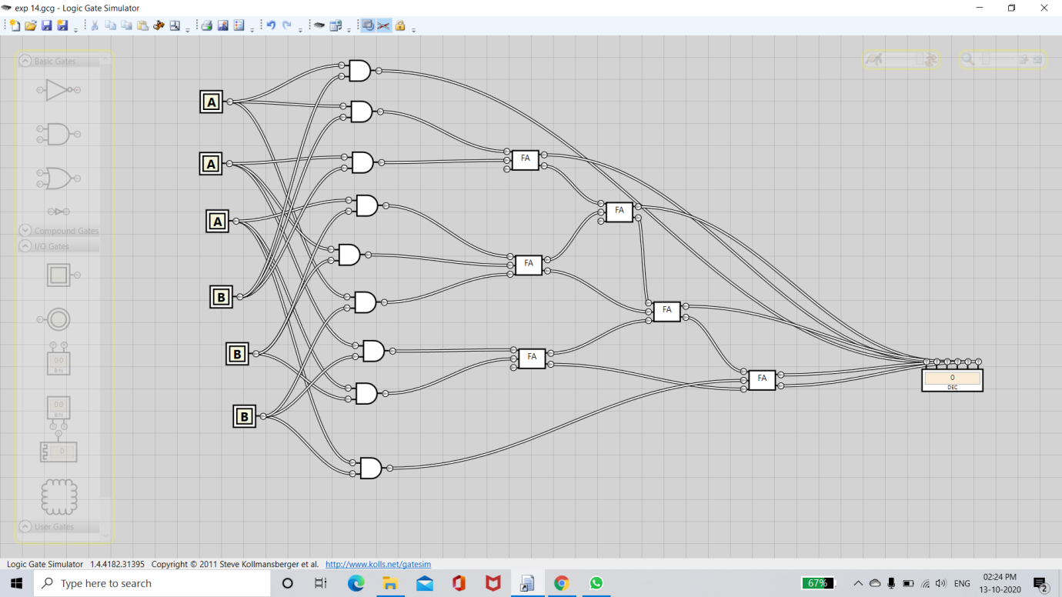

OUTPUT :

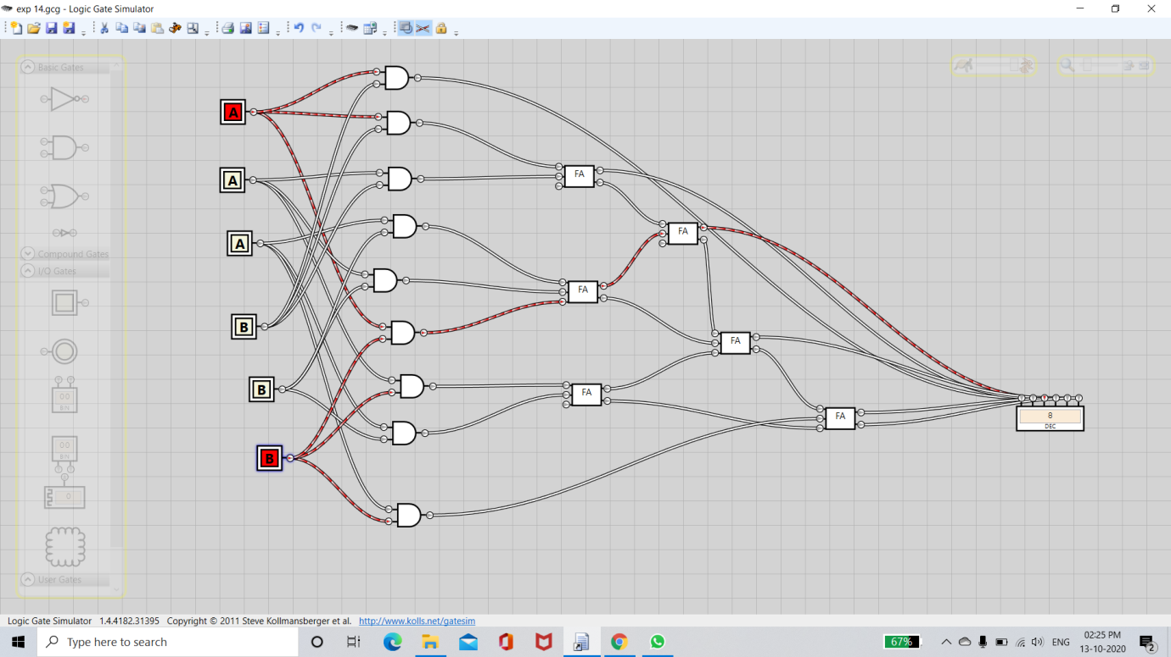

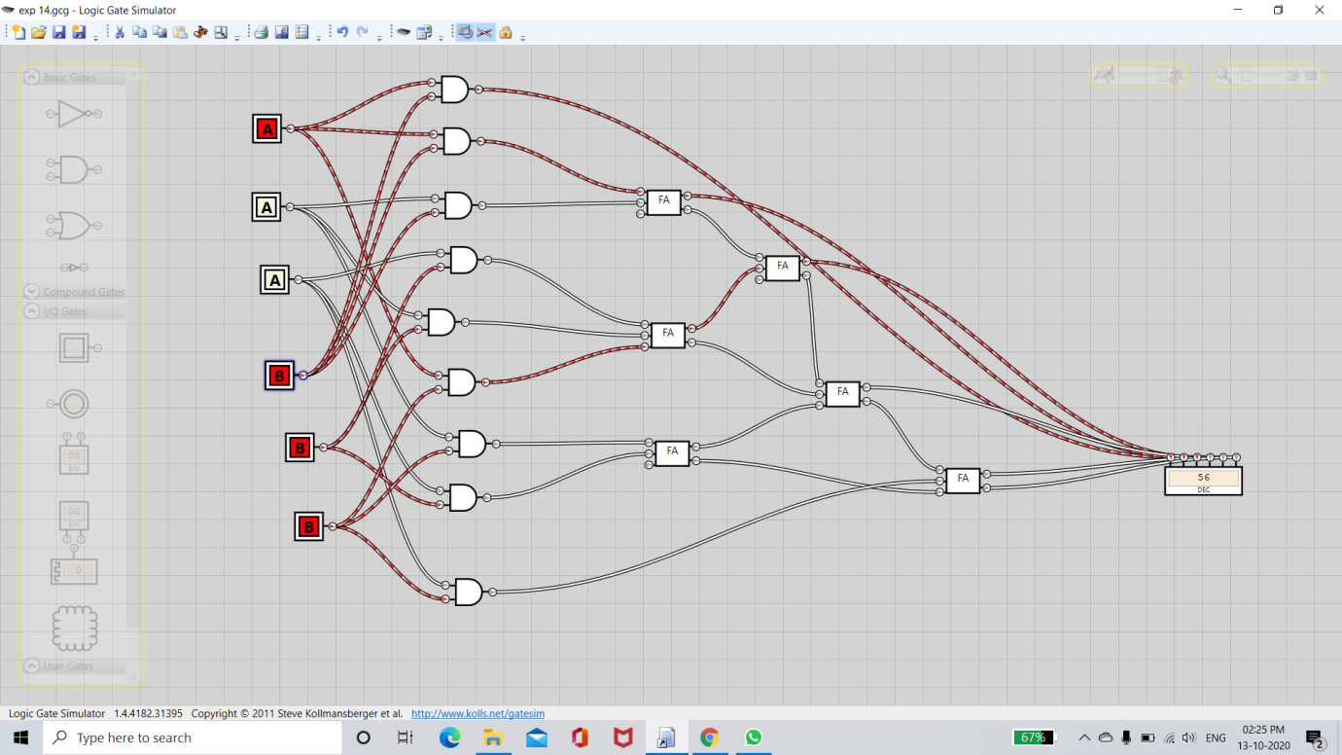

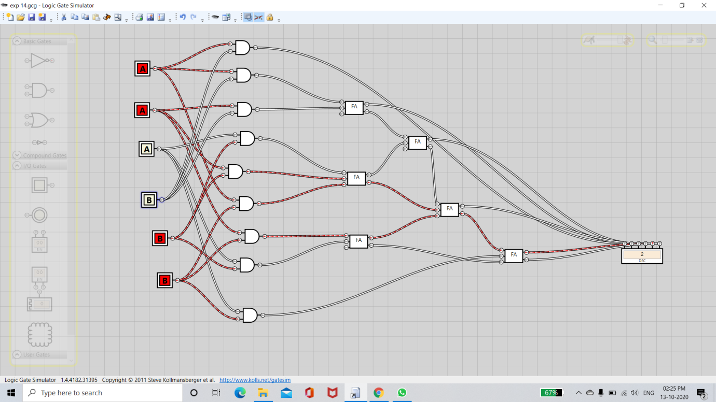

Result:

Carry save multiplier was constructed in simulator & char. were studied.